 |  | Business | Certificate good for:
 |  | Automotive |  | Retail | Sale Price
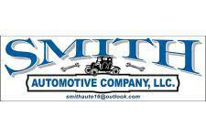  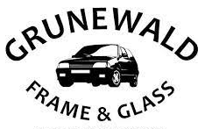 |  | Olsen Trucking Service St James | $50 Certificate | $ 50.00 | $ 35.00
 |  | Smith Auto | $100 off set of four tires | $ 100.00 | $ 65.00
 |  | Grunewald Frame & Glass | Regular Oil change up to 6 quarts | $ 41.51 | $ 25.00
 |  | Grunewald Frame & Glass | Synthetic Oil Change up to 6 quarts | $ 65.03 | $ 40.00
 |  | Entertainment |  | Retail | Sale Price
 |  | Arnolds Park | One Day Pass to Amusement Park Rides | $ 34.95 | $ 23.00
 | 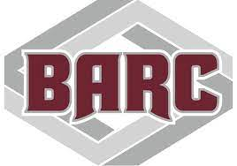  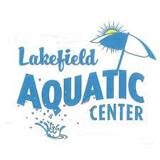 | B.A.R.C. | $60 Room Rental Certificate | $ 60.00 | $ 36.00
 |  | Lakefield Aquatic Center | One Day Pool Pass | $ 6.00 | $ 4.00
 |  | Murray County Speedway Slayton | One Night Race Pass | $ 12.00 | $ 7.00
 |  | Princess Theater | 4 pack of Movie tickets | $ 20.00 | $ 15.00
 |  | Wild Water West | One Day Adult Pass | $ 30.00 | $ 15.00
 |  | Windom State Theater | $10 Concession coupon certificates | $ 10.00 | $ 8.00
 |  | Food Certificates |  | Retail | Sale Price
 |  | American Legion Post 41 Lamberton | $10 Certificate | $ 10.00 | $ 8.00
 |  | Bergan Meats | $10 Certificate | $ 10.00 | $ 7.00
 |  | Ground Round Worthington | $10 Certificate | $ 10.00 | $ 8.00
 |  | Highwater Creek Meat Market Jeffers | $10 Certificate | $ 10.00 | $ 8.00
 |  | Hyvee | $10 Kitchen Meal Certificate | $ 10.00 | $ 8.00
 |  | La Tejanita Lakefield | $5 Gift Certificate | $ 5.00 | $ 3.50
 |  | La Tejanita Lakefield | $10 Gift Certificate | $ 10.00 | $ 8.00
 |  | La Tejanita Lakefield | $15 Gift Certificate | $ 15.00 | $ 11.00
 |  | Shady Drive Inn | $10 Certificate | $ 10.00 | $ 8.00
 |  | The Den | 1$10 Certificate limit 2 per visit not valid for off-sale | $ 10.00 | $ 8.00
 | 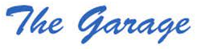 | The Garage Springfield | $10 Certificates | $ 10.00 | $ 8.00
 |  | The Shed Lakefield | $10 Certificate | $ 10.00 | $ 8.00
 |  | Home and Services |  | Retail | Sale Price
 |  | Brown's Shoe Fit Worthington | $10 Certificate | $ 10.00 | $ 8.00
 | 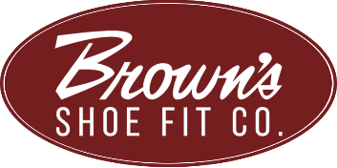 | Brown's Shoe Fit Worthington | $25 Certificate | $ 25.00 | $ 17.00
 |  | Cottonwood County Landfill | $10 Appliance Disposal | $ 10.00 | $ 8.00
 |  | Cottonwood County Landfill | $15 Mattress Disposal | $ 15.00 | $ 11.00
 |  | Cottonwood Vet Clinic | Wellness Exam | $ 10.00 | $ 8.00
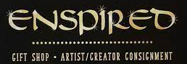 |  | Enspired | $10 Certificate | $ 10.00 | $ 8.00
 |  | Hammers Furniture Windom | Sierra Sleep Limited Edition Firm Full Size Mattress & Boxspring | $ 999.00 | $ 450.00
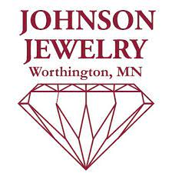 |  | Johnson Jewelry Worthington | $50 Certificate | $ 50.00 | $ 35.00
 | 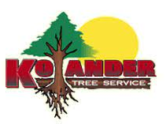 | Kolander Tree Service | $100 Certificate for tree trimming. Removal, stump grinding up to 5" diam. | $ 100.00 | $ 65.00
 |  | Mountain Lake Floral | $10 Certificate | $ 10.00 | $ 8.00
 |  | Ryan's Repair Mtn Lake | $20 Certificate towards small engine service | $ 20.00 | $ 14.00
 |  | Threads and Décor | $25 Certificate | $ 25.00 | $ 18.00
 |  | Cutting Image Hair Stylist & Boutique Lakefield | $20 Certificate | $ 20.00 | $ 15.00
 |  | Hair With Flair | $20 Certificate limit 2 per visit | $ 20.00 | $ 15.00
 |  | Pebbles Massage | $65 Gift Card | $ 65.00 | $ 52.00
 |  | Wolf Therapeutic Massage | 1 Hour Signature treatment (inc. in depth concentrated massage on upper neck and shoulders | $ 75.00 | $ 55.00

